

| DATE: | 15-Nov-2022 |
| --- | --- |
| TEAM ID: | PNT2022TMID37769 |
| PROJECT NAME: | IOT BASED SMART CROP PROTECTION SYSTEM FOR  AGRICULTURE |
| TEAM MEMBERS: | MAHALAKSHMI,PRADAPSINGH,RAJALAKSHMI,  GOKULKANNAN |





STEP1: Login to your IBM cloud account.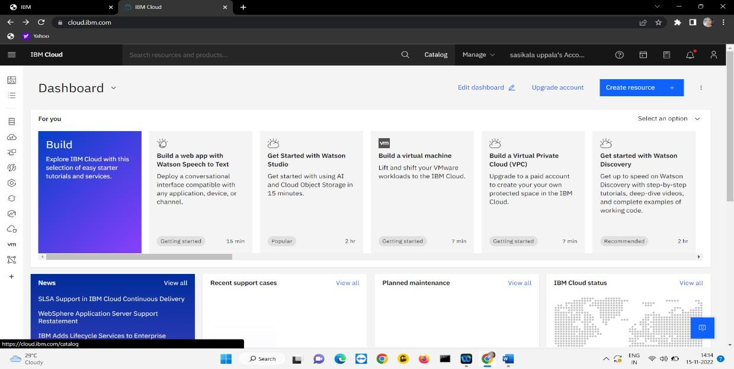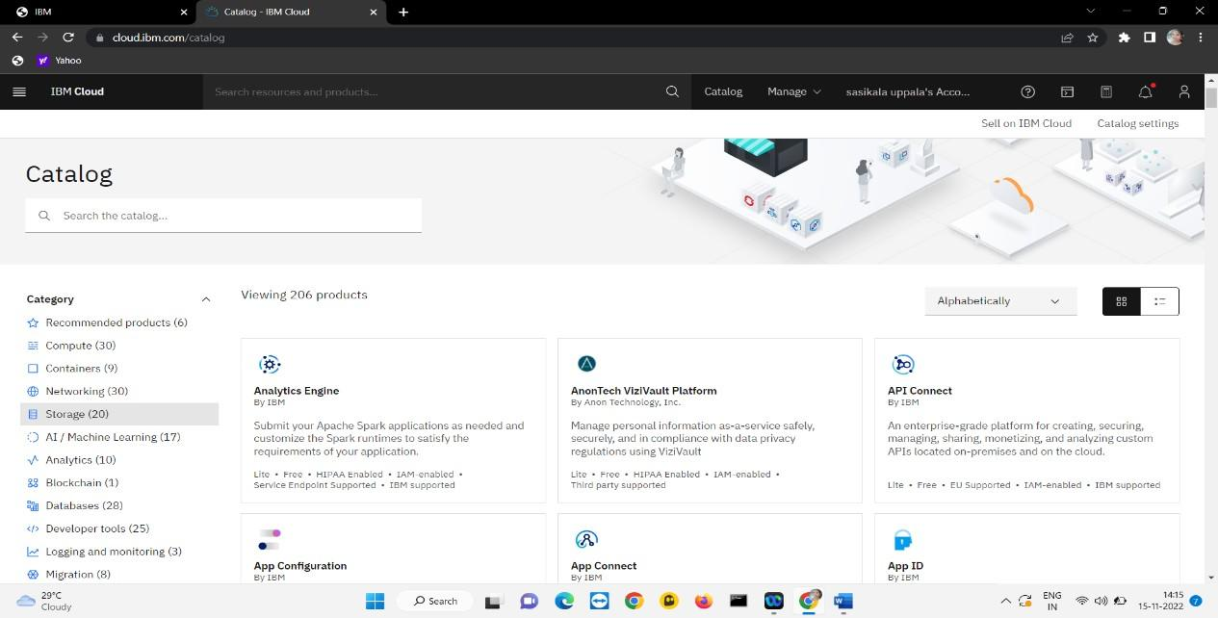





STEP2: Open the catalog. Then click on the storage.

STEP3: Then if you scroll down you observe object storage and click on it.

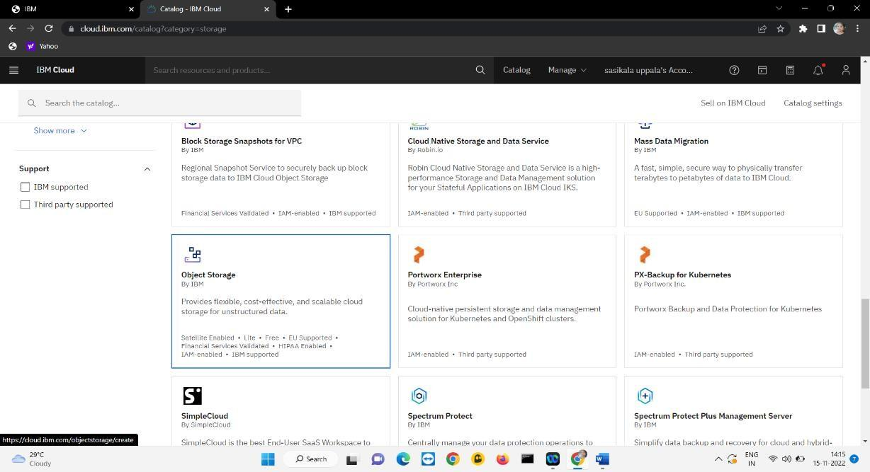

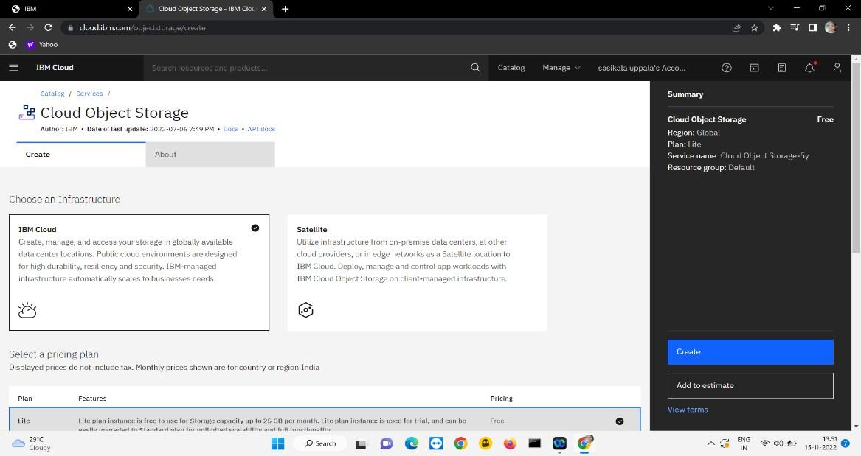

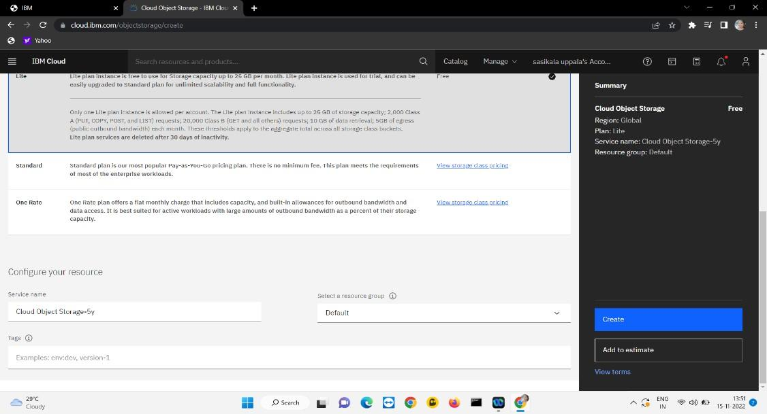

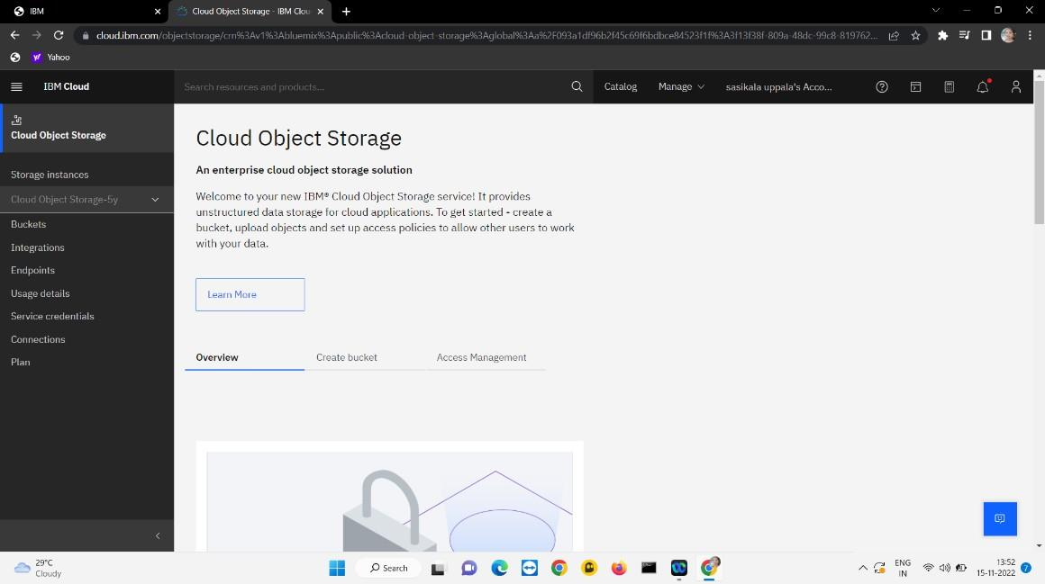

STEP6: To store image we have to create bucket for it. To create bucket click on it and it will show the some option to create bucket the click on custom bucket and it open as shown below and provide details their ask and click on create bucket.

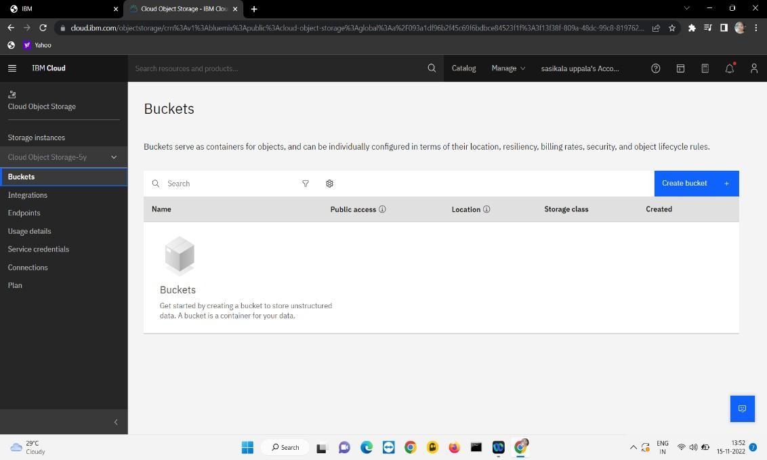

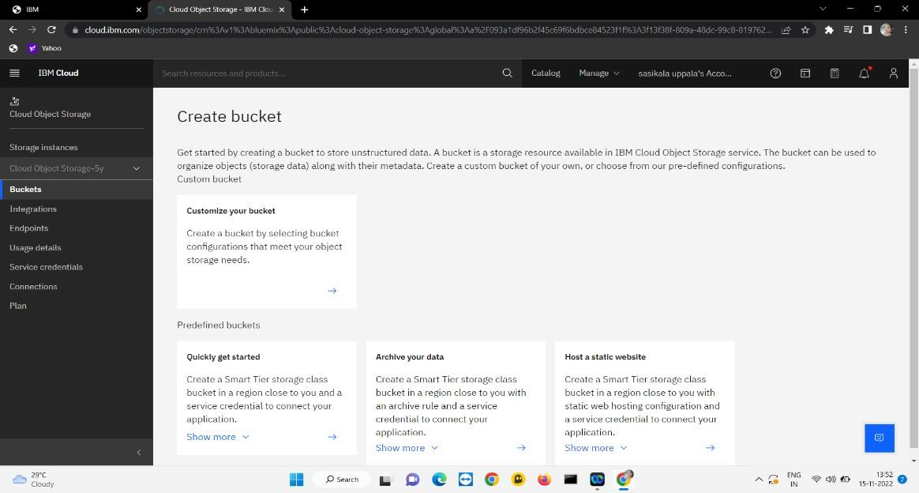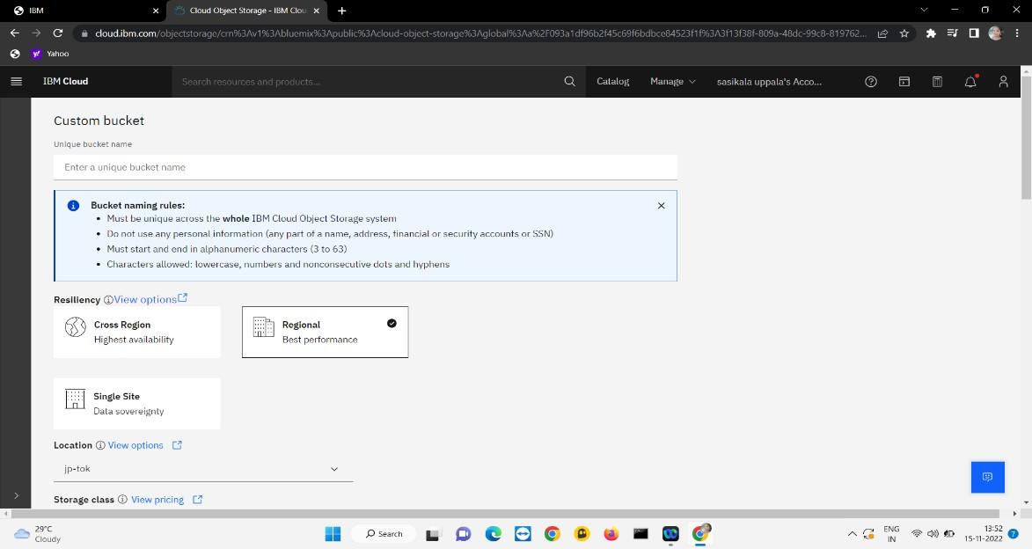

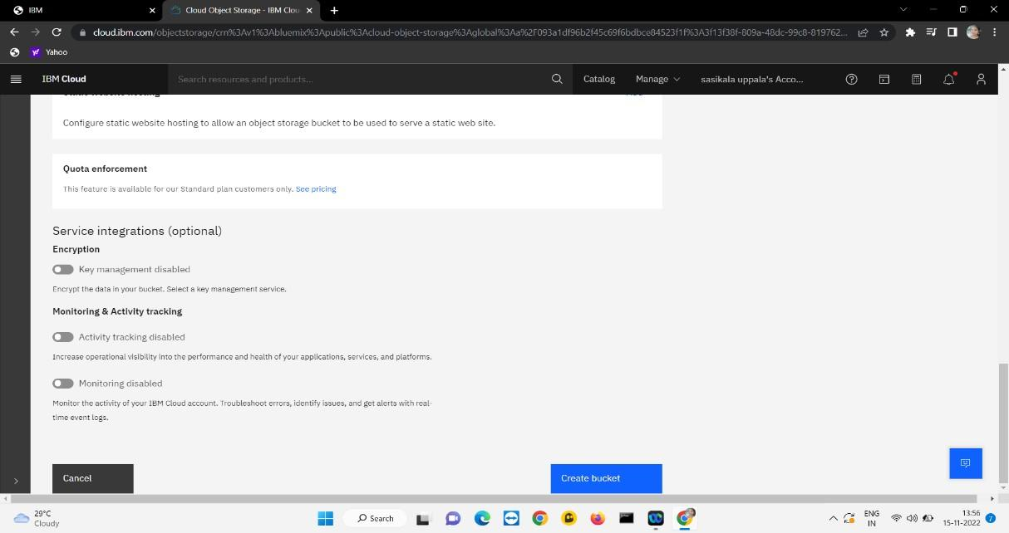



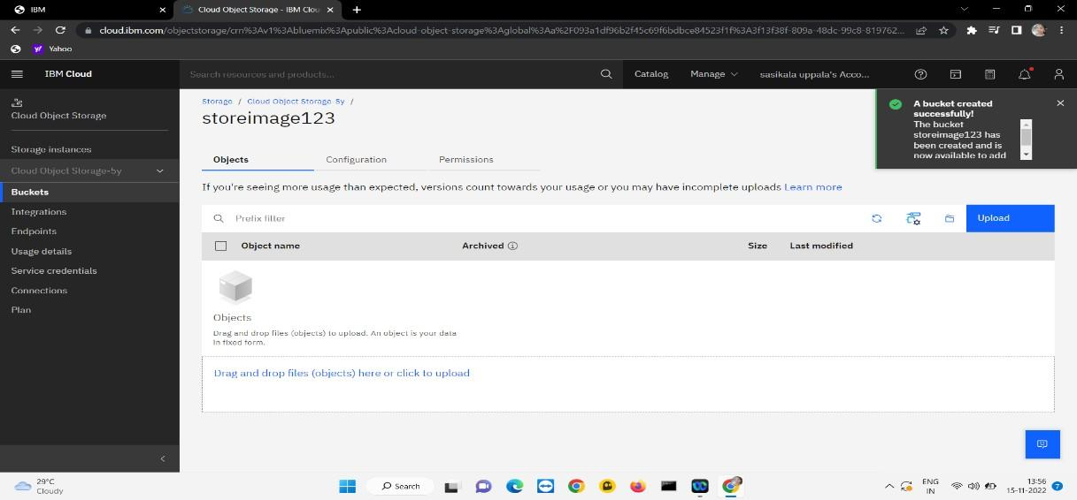

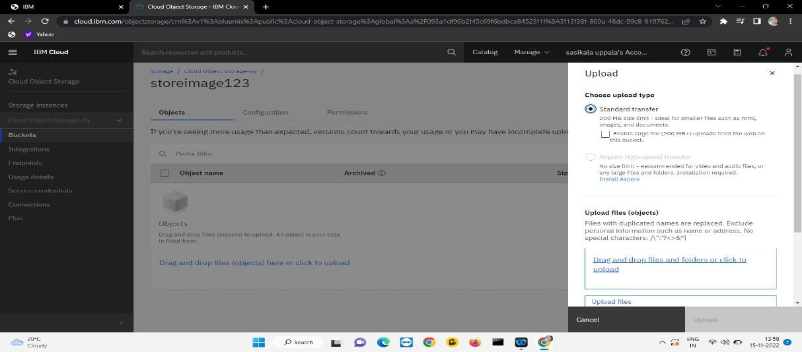

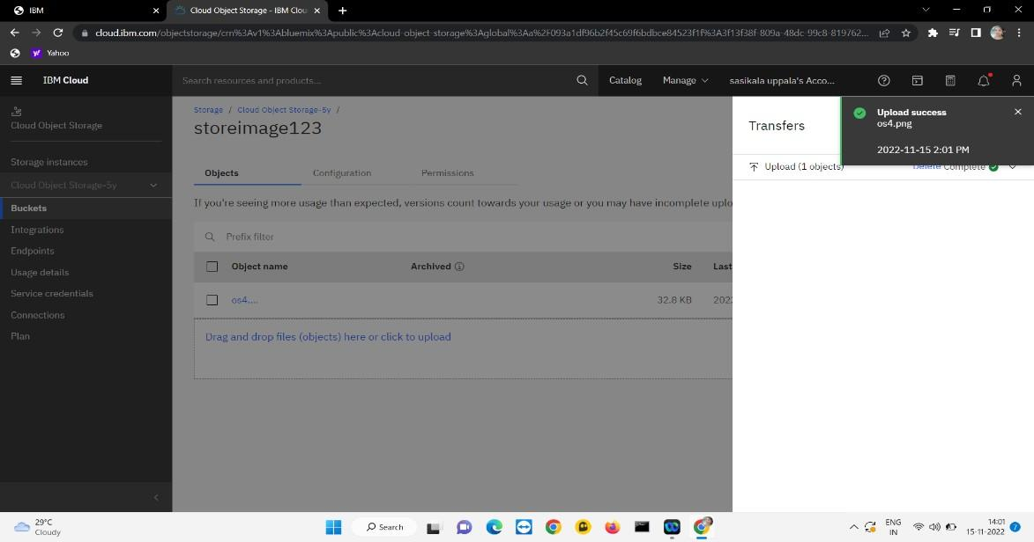

STEP8:Now you can see observe configuration settings as shown.

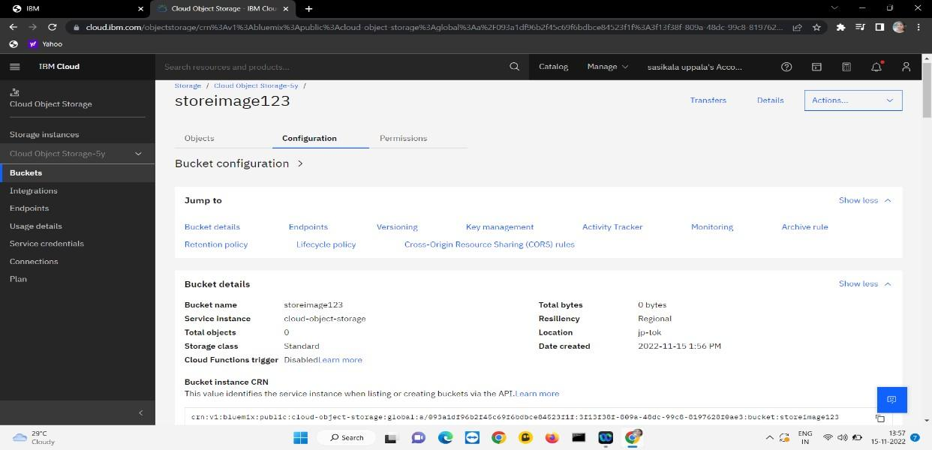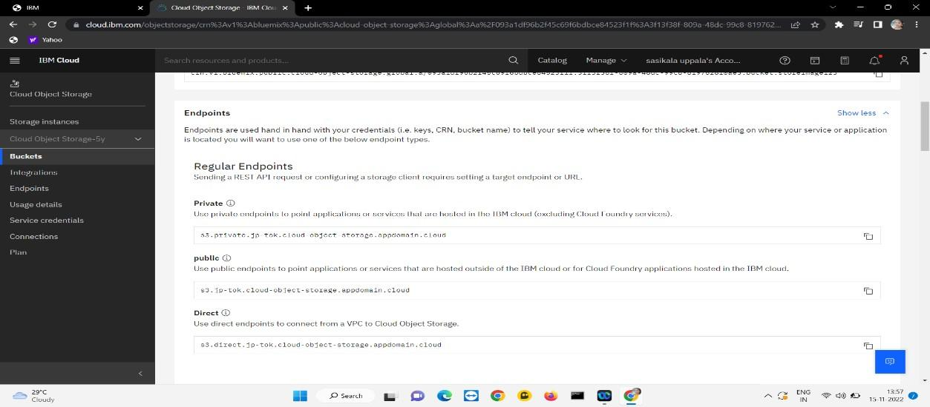

STEP9: Here you can see the endpoints which is used for programming.

STEP10: The important part is service credentials for programming integrity.

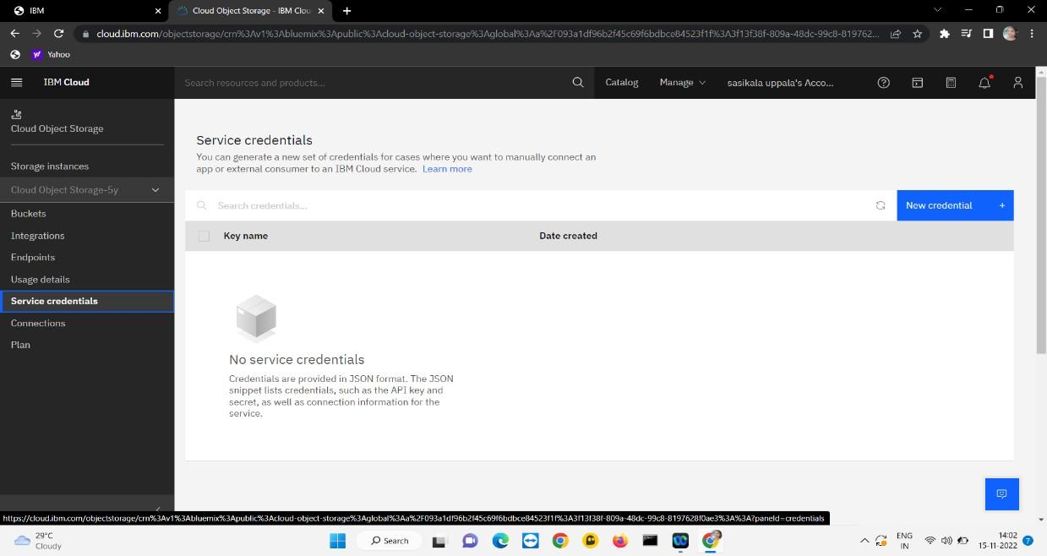

Now click on create credential then you get this the figure below and remember those for programming.

